LDP Workshop

**Workshop 3**

**More on this workshop**

**Refresh, Repair and Compare**

**REFRESH- LDP uses the term Refresh to perform a one-time data load.**

**Refresh is often used for an initial load because LDP automatically aligns the one-time load and incremental CDC to ensure system synchronization.**

**Refresh also automatically maps data types from the source to compatible, loss-less data types on the target, in a heterogeneous environment.**

**Refresh can also be used to create the tables in the target database.**

**COMPARE - With data replication in place, you expect systems to be in sync, but are they?**

**How do you find out? And if they are not in sync, what operations were performed recently that may have caused the systems to go out of sync?**

**To identify whether your data is in sync, LDP provides a Compare capability. Like Refresh and ongoing data replication, the Compare capability is based on the Channel Definition.**

**In this workshop, you will refresh the ITEM table and then run a compare to confirm the table is in sync between the source and targets.**

**Since there are active transactions happening on the ITEM table, LDP needs to have those transactions that are in flight considered. When the refresh and compare are run, they will be run with the online options chosen.**

1. If not there already, navigate to the CHANNELS web page.

*Click* on the top channels icon in the navigation bar on the left side of the webpage

1. This page will show all the channel that have been set up.

*Click* on the blue “ora2mdbpg” channel link to be taken to your running channel

1. You should see your ora2mdbpg channel with the running capture and integrate jobs shown. On the top right are three white buttons listed. They are “Activate Replication”, “Compare Data”, and “Refresh Data”.

1. *Click* on the “Refresh Data” button. This will bring up the “Refresh Data into Target” screen. Set the scope of the refresh by making sure the source is the Oracle database and both the MariaDB and PostgreSQL database are all selected.

*Click* on the “Locations” drop down to confirm that oracle is selected as the source and mariadb and postgres are the targets

*Open* the “Tables” drop down

*Uncheck* all tables except the ITEM table

*Select* the “Create Missing Target Tables and Alter or Recreate Tables with Incorrect Layout”

*Confirm* the “Bulk Load – Table Granularity” method is selected

*Expand* the “Online refresh consistency when selecting tables which are being changed” arrow

*Select* the “Changes before refresh are skipped by both capture and integrate jobs” button

*Click* the blue “Refresh Data” button in the bottom right of the screen. This will start the refresh of the ITEM table.

1. A window will popup telling you the job has started.

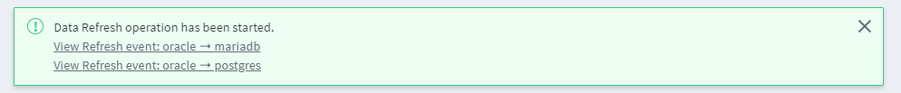

*Click* on the “View Refresh event:” link. This will take you to the Events page and bring up the refresh event showing you the status of the job. Once the state of the job shows as “DONE”, the refresh has completed.

1. *Click* on the “CHANNELS” icon in the navigation bar to return to your running channel.

1. Now that you have refreshed the ITEM table, let’s confirm that it is in sync with the source database. To do this you will use LDP’s Compare ability.

*Click* on the “Compare Data” button on the top right of the CHANNELS page.

1. This will bring up the “Compare Data” screen. Set the scope of the refresh from the “Locations” drop down by making sure the source is the Oracle database and both the MariaDB and PostgreSQL database are all selected.

*Open* the “tables” dropdown.

*Uncheck* all tables except the ITEM table

*Confirm* the “Online Compare” box is selected.

*Check* the “Do Compare Twice and Report Only Differences which occur twice”

*Confirm* the “Wait” button is select with “5 seconds” selected

*Click* the blue “Compare Data” button in the bottom right of the screen. This will start the compare of the ITEM table.

1. A window will pop up telling you the compare operation has started

*Click* on the “View Compare event:” link. This will take you to the Events page and bring up the compare event showing you the status of the job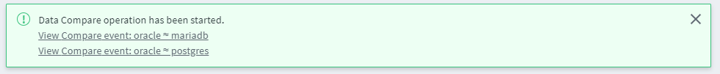

Once the state of the job shows “DONE”, you will see that the table will be in sync with the target by the ITEM table state showing “DONE/IDENTICAL”.

**Conclusion**

The need to refresh a table in replication may come up from time to time. LDP gives you the ability to seamlessly refresh a table and then compare it while transactions are still occurring on the source database. This workshop walked you through the process of refreshing a table and then comparing it to confirm it is in sync with the source database.